5.8: a) Since 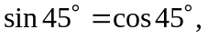 adding the last two equations gives 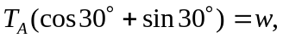 and so 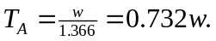 Then, 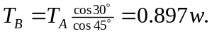
b) Similar to part (a), 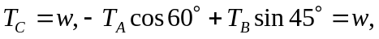 and 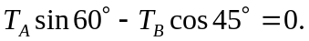 Again adding the last two, 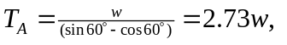 and
